Work Stations Rubric
 | As a team member I: | 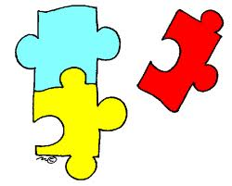  As a team member I: | As a team member I:
 | ___ did not stay on task and do all my work | ___ stayed on task a little and did some of my work | ___ stayed on task and did all of my work
 | ___ did not help my group solve problems | ___ only helped my group when they asked me | ___ helped my group solve problems
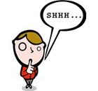 | ___ did not have a quiet inside voice | ___ had a quiet voice some of the time | ___ had a quiet voice, so I did not disrupt the other groups
 | ___ did not give my best effort on my work | ___ put a little effort into my work | ___ gave my best effort on all my work

