Julie Kalvels’ Writing Notebook
For my writing notebook I’m going to do a brainstorming activity I read about recently in an article. They recommended setting a timer, think of a word or phrase and just start writing (or for me typing) whatever you think of for a certain amount of time. Each week I’m going to write for 5 minutes. (After writing, I changed it to 10 minutes)
Week 1: Student Engagement
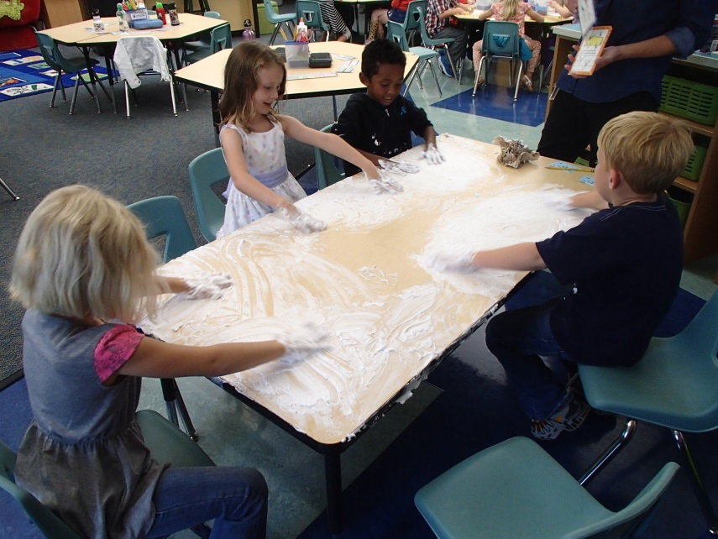
I just started the timer on my phone for 5 minutes. This week I’m going to talk about my thoughts on Student Engagement. This is one of the 5D (five dimension) elements of good teaching our district is implementing. I’ve recently been asked to think of a professional learning goal I’d like to set for myself this year. I’m meeting with my principal on Monday at 2:00 to talk about my goal. I’ve decided to make my goal come from the dimension of student engagement. I think it’s important for the kids to have and find their voice in the classroom. Giving students a choice in their assignments can help achieve this. But how do I give Kindergarteners more ownership of their work? This is a challenge I’d like to tackle this year. I forget each year at the beginning how much they don’t know. Routines and things I took for granted with last year’s class were already in place. How do I give ownership to kids who don’t know routines yet? I would like to give more choice, but how? Perhaps I should wait a few months and develop routines and expectations with my class first and then work toward giving them choice. Right now I have one or two parents that come in my room to volunteer each day. So I have one parent at each center. I value my parents, but I wonder, are they teaching the children at the tables or are they don’t the work for them! Would my kids be better off struggling on their own and figuring out how to do a task by themselves rather than having a parent there to answer every question and hold their hand? I just looked at my phone timer and it says 10 minutes now! Wow! Ok, I guess I went over the 5 minutes mark. I think this exercises of brainstorming was great. It forced me to put my feelings down on paper. I have to admit I was a little nervous at first. I felt like I had to type fast to get a lot down in 5 minutes. I was making lots of errors and the red lines were popping up for mistyping words. I just went with it and after a while it became more natural. I will go back now and correct all the spelling errors though!

Week 2: Quiet Time
Ok, just pressed go on my timer! I’m excited about writing about this topic. Quiet Time! We have 15-20 minutes of quiet time in my classroom every day after lunch. Is this a good use of time? Do Kindergarteners need a quiet time? Or is this just a time for teachers to check their email and set up activities for the afternoon. I constantly have to remind the kids not to talk, but use their whisper voices. They giggle and are squirmy. They are allowed to look at books. They are sharing books, holding up books to each other pretending to read and be the teacher. This can be valuable right? Or is this time better spent having them at their tables free writing in a journal. After reading last week about journal writing and letting the kids write what they want to write, I’ve realized that I don’t really do that. I suppose this could be a way for me to allow more choice in my classroom too. The students can have quiet journal writing time after lunch. My children are at different stages, so this could be having drawing pictures, sounding out some words, writing the alphabet or numbers, making a list or writing words from around the room. They can have a choice! I just looked at my phone and it said 7 minutes. I think my original time of 5 minutes is not enough. I think next week I’m going to change the time to 10 minutes! See you next week! 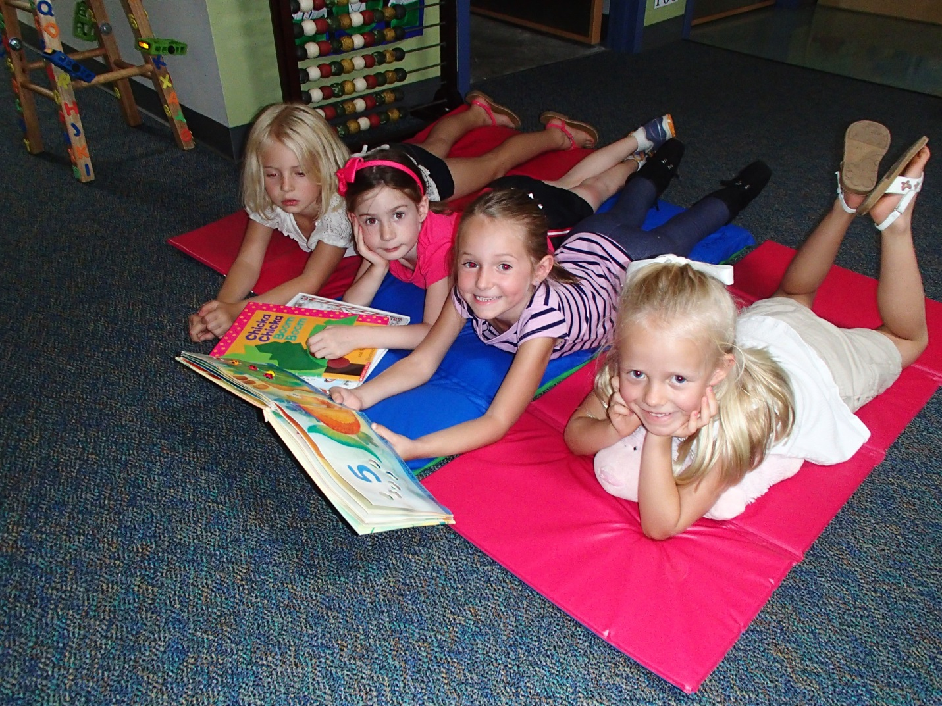

Week 3: Competition
Ok, I’m starting again. This week I’ve decided to write about competition. I am a very competitive person. I have two sisters, one a year older than me and one a year younger than me. Since we are close in age I think I’ve grown up trying to outdo the other two. Even now that I’m married I’m still competitive against my husband. Just the other day we were driving home from our softball game in two separate cars. He got caught by a light and I beat him home. As soon as I saw him I said, “ha ha, I win.” That’s ridiculous, why am I so competitive? I can’t help it though. We are on a Fantasy Football team together. When we play each other it’s so much fun because we can route for our own players. One time his team one and I was mad, on the inside, not on the outside. I didn’t let him know of course! I think competition is everywhere we go. You cannot get around it. In my last school we were not able to play field day against teams because they did not want to encourage competition and winners and losers. But let’s face it. In life, there are winners and there are losers! Our kids need to be taught how to be a good winner and a good looser. I have competition in my Kindergarten room. We have table points. The table with the most table points at the end of the month gets to eat lunch in the classroom with me. The kids love it! Competition is all around. Food, retail, cars, jobs, houses, anything I try and think of has competition! Time’s up! Put down my pencil- or in this case- fingers off the keys!
Week 4: Cell Phone Etiquette
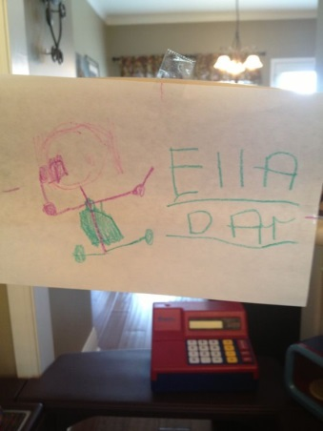
Cell phones! Oh, we all love them, but we love them too much and don’t know when and where it is appropriate to use them. This topic is one that is on my mind a lot. I get annoyed when I am in the grocery store and see someone talking on the phone. You are at a grocery store!!! Shop! Don’t talk. Just this week the person in front of me was checking out. She was about to pay and her phone rang. She answered it and said, can you hold on a minute I’m checking out. Why answer the phone in the first place lady!!!! It made me start to think of proper phone etiquette. When my husband and I are eating dinner we never answer our cell phones! Why? The answer was that both our parents had that as a rule in our houses growing up. It was instilled in us that it was rude and unacceptable to answer the phone when you are at the dinner table. That has carried over into our house in regards to our cell phones. Our parents did not grow up with cell phones, therefore was not able to teach us proper cell phone etiquette when you are around town or talking with another person. We need universal cell phone etiquette. We are not teaching today’s kids how to use them responsibly. When you are having a one on one conversation with a friend or family member and your phone rings are you supposed to answer it. I think it’s rude! My teaching colleague has stopped talking to me and engaged in a conversation on her phone multiple times. I think it’s rude. Was my conversation not good enough! Ha ha! My sister has a little three year old. She recently drew a picture of herself talking on a cell phone holding up her finger to my sister. My sister asked her about the drawing and she said she was pointing her finger saying, “stop, I’m talking on the phone” Ha ha! I wonder how many times my sister has been talking on her phone and pointed to Ella, my Niece, saying stop! That picture speaks loudly! Here is the picture!

Week 5: Patio
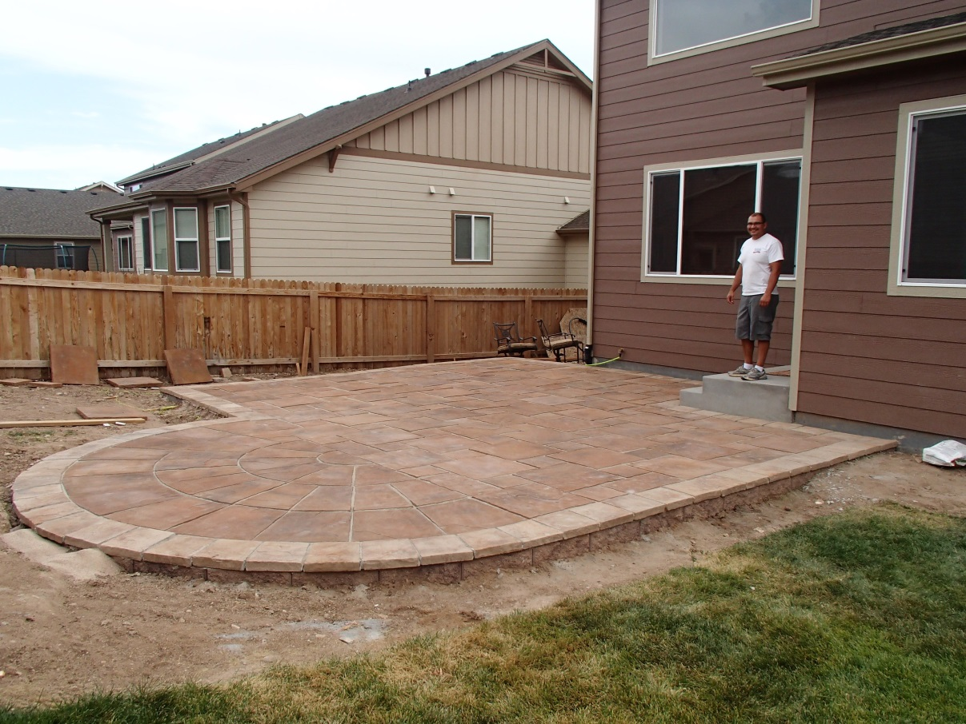
So today is Saturday morning and I’m so excited. My husband and I are going to go shopping for some patio furniture for our new house. We bought our house almost a year ago. We have been working hard all summer building a huge paver stone patio. Well, I guess, not too much of we, more like my husband. It has been his summer project and thing to do on the weekends since most of my weekends have been spent on graduate school work. We originally were going to be having it done by a professional. We had several people come by and give us quotes. Pretty much we would be paying about $20,000! Yes! CRAZY! I could buy another truck for that amount. So we started doing it ourselves little by little. We took 20 tons of dirt out of our yard in a half size Toyota Tacoma pick up. Shovel by shovel, truck load by truck load we took the dirt out. We had to dig out 12 inches the entire length of the patio. Erik figured out he percentage of slope we needed for the water to flow off the side and away from the house. We put Alan block stones surrounding border of the patio. We put rebar and cement in every single one. Our patio is not moving anywhere! We went a little overboard of the foundation. Better be safe than sorry! Then we had a dirt party, with 20 neighbors and friends helping us move 28 tons of roadbase from the street to the backyard. Then came the hard part, we had to level out the sand and lay the stones. It took about a week to lay all the stones. Each of the bigger stones weighed 88 pounds. Erik went through 3 pairs of gloves throughout the entire project. Now it’s done! It only cost us about $6,000 and it looks fantastic! We are so proud of the patio. Each day we get home from work we look back there and can’t believe we did it on our own. And it looks like a professional did it too! If we were to do it all over again we would do it ourselves again. We appreciate all the hard work that went into building it. So today is a great milestone. We get to buy furniture, sit down with a glass of wine and enjoy the beautiful patio!!!!!!!

Week 6: Field Trips
On Thursday we went on our first field trip to Miller Farms. It was fantastic! It was many of my kids first time riding on a bus. We all piled into a huge tractor that took us around the farm where different crops were being grown. We each had a bag and got out at each stop and picked vegetables. It was an incredible experience for our kids to see how each vegetable was grown. We picked corn, potatoes, cabbage, carrots and a pumpkin. The next time they go grocery shopping I bet they will think about this experience as they are picking out produce and putting them into their cart! I took my iPad and camera along for the ride. I’ve never created an Animoto video using pictures and video footage, so I wanted to give it a try. I loved it! I created a video of our trip with pictures, videos and music in the background and it was easy! I would recommend it to anyone. Here is the link if you are interested: http://youtu.be/leDAcwKcm3g
We are going to be doing something else new next week. We are going to be Skyping with another Kindergarten class. Amy Moran, another Kindergarten teacher, who I met through our Regis classes, is going to be our blogging buddies this year. They went on the same field trip to Miller Farms a day after our class went and we are going to Skype together to talk about our experiences. I’m excited, but a little nervous too. I told my principal about it, so she is going to come and observe. I don’t know why, but I can’t act natural with her around. I get so nervous!!! Maybe next week I can write about the Skyping experience.

Week 7: Blogging
At the beginning of the school year, I set up an account with the blogging site kidblog.com. I gave my students passwords and each child has the opportunity to have their very own blog. It is password protected and only students and parents from our class would be able to see the posts. It’s October now and I have yet to introduce my Kindergarteners to blogging! Why? I think I’m a little nervous. I don’t know how to introduce it to my class or where to start. Do we blog only in the class or computer lab? My kids can’t type yet, but they can sound out letters and try. What kinds of activities could I do to have them blogging? Is blogging a good medium of writing for Kindergarteners or should teachers wait till the kids are older? I have so many concerns and questions about the unknown to me because it is something new. I wonder if this is how my kids feel about doing things that are new to them. Maybe I should just dive in and start my kids with blogging. It might not go the way I have planned, but I can learn from my mistakes for the next year’s class. If I keep putting it off and questioning myself then it will never happen. I only have one more class in this reading and writing class with Regis and my next class will by Multimedia 2. I’m hoping that I can use KidBlog with my kids to complete some assignments in that class. I am going to make it a point to start researching ways and ideas of how I can blog with my Kindergarteners!

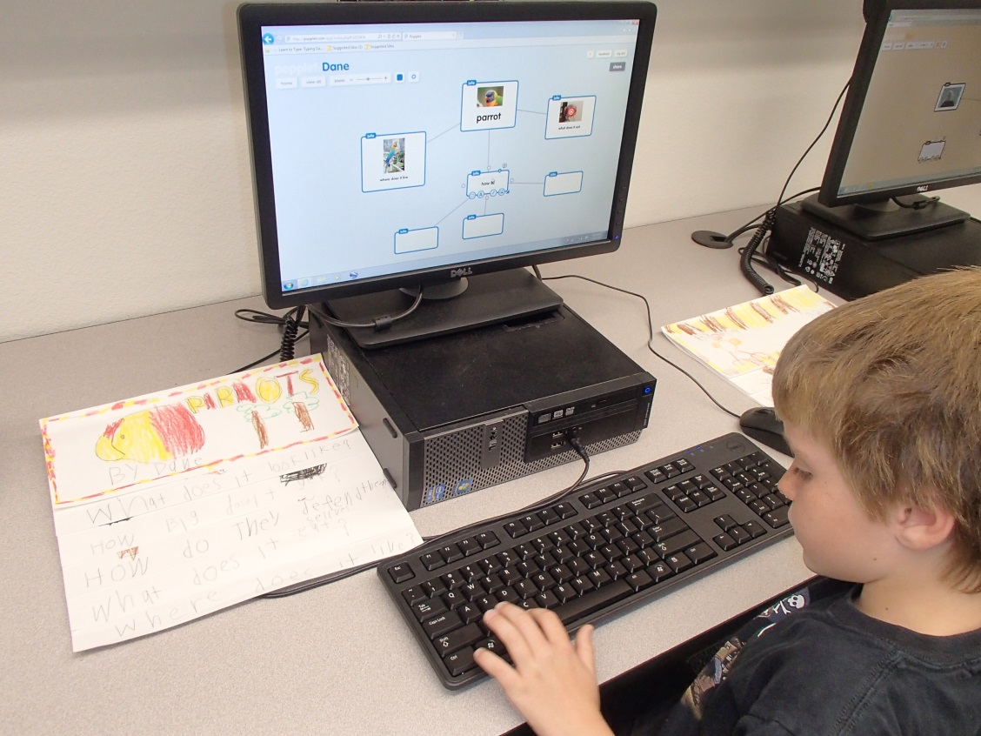

Week 8: Justin Mattot (Children’s Author)
On Wednesday this week we had a guest author speak at our school, Justin Mattot! He has written over 30 children’s books and was very inspirational in his message to the kids. He talked about keeping a writers notebook and all his ideas and books came from every day experiences that had occurred at one point or another in his life that he had randomly written down in his journal. He was funny, engaging and even inspired me to want to write a children’s book. I started to think in my head, “If I were to write a book, what would I write about.” I came up with lots of different things that have happened in my life. My husband and I bought a new house recently. We had it built and it was a joy to see the step by step process. When we moved in everything was brand spanking new. I didn’t want to mess anything up. In class this week we read a book called “Hey, Little Ant.” It was a children’s book written by an ants perspective of life. This got me thinking. I could write a children’s book about a new house being “Sold” and dealing with new occupants moving in, written from the houses perspective. This is the last week of our class and doing these timed writings. We are to choose two writings and complete them in final draft form. I think one of these writings I’m going to write a children’s book entitled “Sold.”

My Reflection on Keeping this Writers Notebook
By Julie Kalvels

When I first read that I was going to have to keep a writers notebook I was a little turned off and thought of it as “work.” After 8 weeks of actually keeping it, my feelings have changed. I’ve realized that reflecting on work, school, home life, random thoughts, no matter what the subject was is a very therapeutic process. It forced me to form opinions and think about a certain topics deeper. Each week I’ve scrolled back through my previous writings and I was proud of them. It’s hard to describe, but putting something in writing meant that it was real and that my thoughts mattered.
In school, I never enjoyed writing. I think it’s because I knew someone else was going to be reading, judging and grading my work. I felt vulnerable. I have kept a journal in the past when I was traveling overseas and hiking for several months at a time. I enjoyed it because it was for me and only me. I feel the same way with this journal. I think that’s why I decided to forgo putting my entries in a blog on the web for all to see and put them into a word document instead.
I learn every day by reflecting on my actions. This is important to note and portray to my students too! I learn by reflecting in my head and by writing it down. I didn’t realize how much I reflect every single day until now. As an experienced teacher I naturally reflect on every lesson I teach. I am constantly learning what works and what doesn’t each time I teach. I often times think to myself, “Yeah, they all got it!” or “Wow, that was horrible!” I automatically think in my head “Why” what went wrong and what can I do to make it better next time. It helps to talk to my colleagues about particular things I’m struggling with and see if they are struggling too or if they have a great way to teach a particular concept. And what’s funny is that what works one year doesn’t always work the next. Each year is unique and my kids react differently to my lessons. I don’t think I realize how much I reflect upon my teaching because it has become like second nature to me. I just see it as good teaching. Reflective teachers are more likely to develop reflective learners. If teachers practice reflection themselves then we can more effectively encourage learners to reflect and improve their own learning.
Reflective practice is the key to improvement. If we don’t think about, analyze and evaluate our professional practice we cannot improve. The same can be said for our precious kiddos! I think my kids need to know this.

