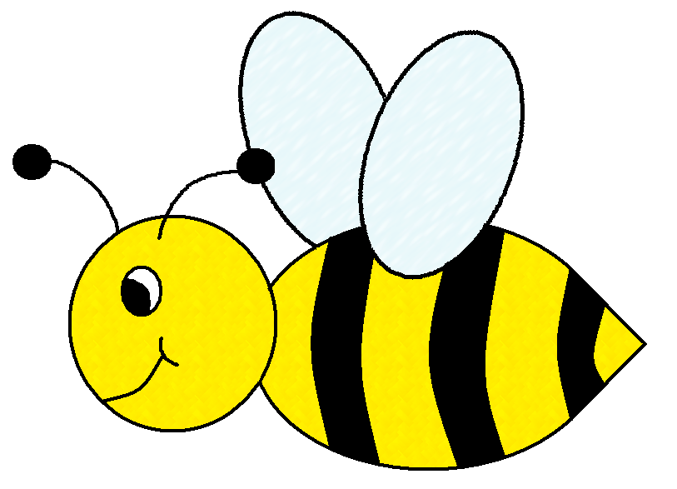

A Kindergarten Guide to Creating Responsible Digital Citizens

Created by:
Julie Kalvels – Bethke Elementary
Amy Moran – Peak to Peak Charter School
July 20, 2013

TO “BEE” A RESPONSIBLE DIGITAL CITIZEN
WE SHOULD…

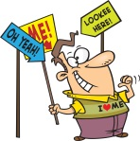
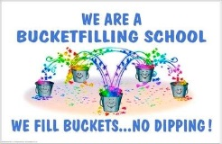
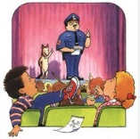
be watchful of time and your
space when on-line

be a careful clicker
be a
Technology
Shining Star
be aware that you are
talking with real people
be fair with
other people’s
work
be proud of your on-line work
be a Bucket Filler
be nice, be positive, be engaged
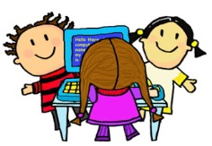
be
protective
of
you
and
your
stuff

Resources

A simple guide to all that teachers need to know about digital technology and citizenship (n.d). In Educational Technology and mobile learning [Web Page]. Retrieved July 19, 2013 from: http://www.educatorstechnology.com/2012/08/a-simple-guide-to-all-that-teachers.html

Digital Citizenship home page:using technology appropriately (n.d.). [Web Page] Retrieved July 19, 2013 from: http://www.digitalcitizenship.net/Home_Page.html

Digital citizenship kids’ pledge [PDF]. Retrieved July 19, 2013 from: http://www.digitalcitizenship.net/uploads/KidPledge1.pdf

Family Online Safety Institute (2010, December 7). Digital Citizenship: Safety, Literacy, and Ethics for Life in a Digital Age . Retrieved on July 19, 2013 from: http://www.youtube.com/watch?v=h8YFAeCi8IA

Murray, J. (n.d.). Digital citizenship in Ask a Tech Teacher [Web Page]. http://askatechteacher.wordpress.com/great-websites-for-kids/digital-citizenship/

Ribble, M.; Bailey, G.; Ross, T. (2004). Digital Citizenship: Addressing appropriate technology behavior [PDF]. In Learning & leading with technology; 32, 1. Retrieved on July 19, 2013 from: http://www.digitalcitizenship.net/uploads/1stll.pdf

Mrs. Moran’s top 10 SAFETY TIPS for using Computers, iPads and other Technology
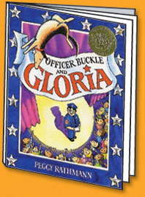
Technology is a powerful tool that brings new and interesting experiences to our classroom through games, researching, and collaboration. We can learn many things and share what we have learned with others by using the technology (the SMART board, computers, iPads, and iPods) in our room to access the Internet and other tools. We have rules in place, just like Officer Buckle and Gloria to keep us safe and our equipment safe, and we need to always remember them when we are using this technology.
Rules for Mrs. Moran’s class according to Officer Buckle (& Gloria):
Safety Tip #1:
We know that it is important to follow the rules to keep us safe
Safety Tip #2:
We learn how to use the Internet safely to help us discover new things
Safety Tip #3:
We tell a teacher if we see anything that is not okay or makes us feel unsafe on the Internet, and help our friends do the same
Safety Tip #4:
We only use our first names when we are communicating with other people electronically and we only talk to people we know
Safety Tip #5:
We learn to keep our passwords SECRET (shh!!)

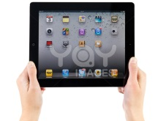
Safety Tip #6:
We know that we need to keep the technology safe in our room – no drinks or food nearby, always have clean hands when using it, and ALWAYS carry portable equipment with 2 hands

Safety Tip #7:
We know to never add ‘apps’ or programs to iPads, iPods or computers in our classroom and only use sites that are approved by our teacher
Safety Tip #8:
We know tell an adult if something is wrong with our equipment
Safety Tip #9:
We know not to copy someone else’s work because there are rules to keep their work safe
Safety Tip #10:
We know that using technology is a privilege and we know that there are consequences if we make poor choices – every student is responsible for his/her own actions while using the technology in our room

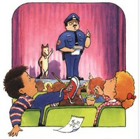

I will take the Safety Tip Pledge and be a Technology Shining Star

Name: __________________________ Date: __________________

I know all my Technology Safety Tips and can tell them to you, just like Officer Buckle!

I am a
Technology Shining Star!

Resources
Acceptable Use Policy (2013, January). Acceptable use policy - Early Childhood, Kindergarten and Grade 1. Retrieved on July 14, 2103 from: http://www.southbank.net/assets/documents/Acceptable-Use-Policy-2013-website.pdf

Brycial, W. (n.d.) Acceptable use policy for Mr. Brycial’s Kindergarten Classroom [PDF]. Retrieved on July 13, 2013 from http://coeweb.astate.edu/brwilliams/AUP/AUP[1].pdf

BVSD’s appropriate use of technology resources for students (2010). [PDF] Retrieved on July 9, 2013 from: http://schools.bvsd.org/p12/Centennial/School%20Info/counseling/201213%20Registration%20due%20May%2011%202012/Appropriate%20Use%20of%20Technology%20Resources%20for%20Students.pdf

BVSD’s student use of the internet and electronic communications (2012). Retrieved on July 9, 2013 from: http://www.bvsd.org/policies/Policies/JS.pdf

Columbia Public Schools (n.d.). In https://sites.google.com/site/ipadsincps/. Retrieved on July 16, 2013 from: http://ipadsincps.weebly.com/uploads/8/1/3/8/8138795/ridgewaystudentusage.pdf

Getting started on the internet: Developing an acceptable use policy (AUP). (n.d.). In Education World. Retrieved on July 12, 2013 from: http://www.educationworld.com/a_curr/curr093.shtml

Kindergarten computer policy [PDF]. Retrieved of July 14, 2013 from http://classifiedmom.webs.com/Kindergarten%20Computer%20Policy.pdf

