Bethke Elementary



Kindergarten Tips to Success
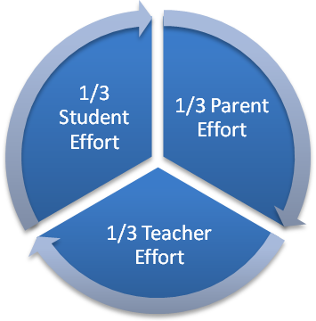

Approach to Reading Instruction

- Lots and lots of reading for all sorts of purposes.

- Modeling of reading and writing in many different forms.

- Phonics Instruction.

- Reading strategies to use when figuring out unknown words.

- Instruction that is appropriate for each child’s individual needs.

- Total acceptance of the child and their attempts at reading.



Ways to Help Emergent Readers at Home

- READ, READ, READ.
- Be a reading model – If a child sees you reading they will get the message that reading is a valuable and pleasurable experience.
- Read Aloud to Your Child
- Language learning consists of input and output. Reading aloud to children is the input. The output is retrieving and using the language learned from listening to the story.
- After reading retell the story. Talk about parts of the story that your child liked.
- If your child wants to hear the story again, re-read it.

Tips for Helping Your Child Read

- Picture walk through the story before reading the book. Continue to use picture clues as you read.
- Point to the beginning of each word while reading. This encourages voice/print match.
- Occasionally have your child find a specific word on a page after s/he has read the passage. Be sure to ask, “How did you know that was ________?”
- Talk about the meaning of the story.
- If an error is made ask, “Does that word choice make sense or is there a better choice?” Then check to see if the new word choice matched the letters/sounds.
- Work on fluency (smoothness of voice) and expression. Pay attention to punctuation clues (pausing at commas, periods, etc.)
- Work on sight words. Sight words are an important component in reading. They are words that beginning readers should instantly recognize rather than sounding out.
Tips for Helping Emergent Writers at Home

- Be Patient, involved and joyous with early efforts at writing.

- Praise writing behavior.

- Provide lots of writing materials.

- Read and write many things with your child.

- Emphasize the meaning of their writing instead of looking for perfect spelling.

- Buy word games, puzzles, books and magazine subscriptions.

- Let your child choose what to write about.

- Encourage book making. Write down what your child says, or write a book together.

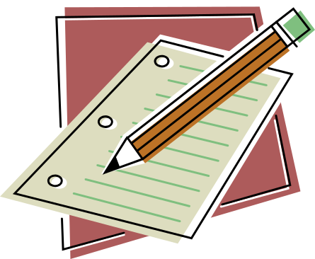

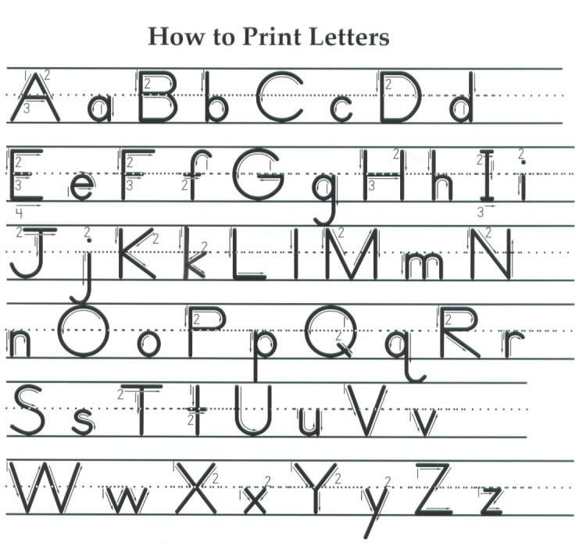

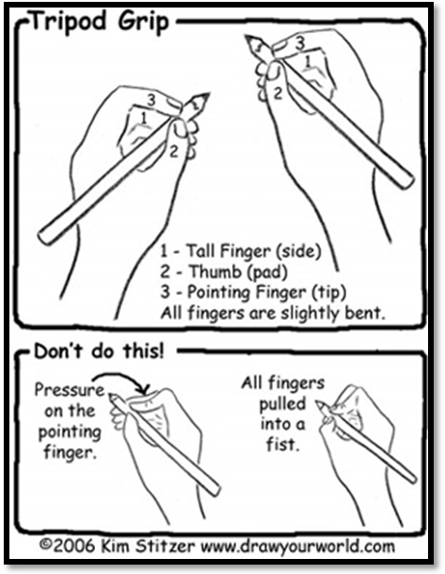
Suggested Pencil Grip
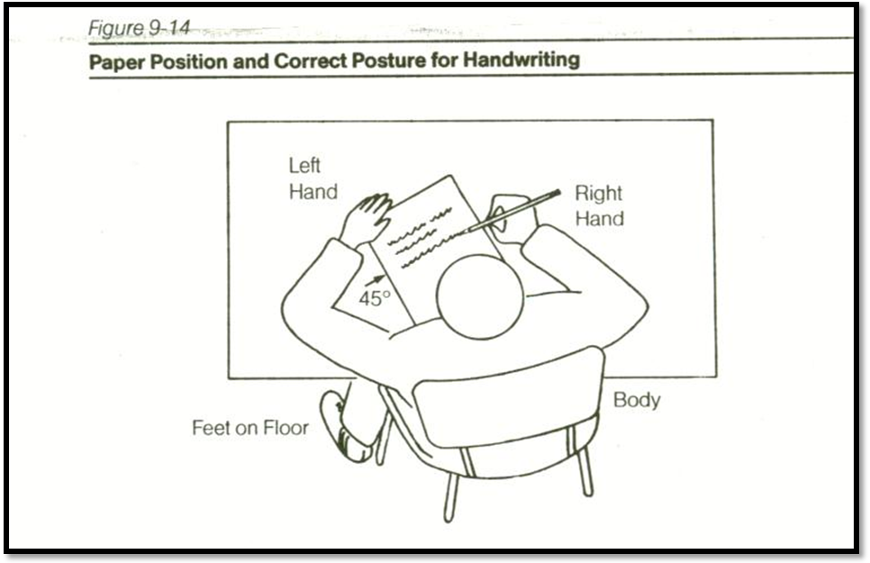

and Posture

At Home Activities

1. Read, Read, Read.
2. Read to a favorite stuffed animal.
3. Pick a topic like bears and read all about it.
4. Visit the library on a regular basis.
5. Find new poems and add them to your Fluency
6. Notebook.
7. Read a chapter book to your child.
8. After reading a book do one of these activities:
- Make a book cover about your favorite part.
- Make a poster about the story or a character.
- Make a paper bag puppet of your favorite
character and present a puppet show.
9. Find words in a magazine or newspaper, cut
them out, and put them in ABC order.
10. Read the poems in your Fluency Notebook.
11. Read environmental print – cereal boxes, signs

Writing Activities

1. When going on a trip, make a trip diary. Use a camera,
and write about your pictures.
2. Draw a cartoon and add the text.
3. Have your child help you create lists – grocery, friends
4. Write letters or notes to family members or friends.
5. Send postcards to a family member in another town.
6. Develop a puppet show.
7. Write stories in a notebook like you do at school.
8. Find pictures in magazine and write a story about them.
Fun Activities

1. Visit the zoo. Have your child read the map, and
signs. After your visit have your child tell you what
they have learned.
2. Weave pot holders.
3. Easy origami.
4. Easy models.
5. Check Michael’s and other local craft stores for
possible ideas and classes.
6. Build with popsicle sticks.
7. Use an ink pad with stamps, or make stamps from
carrots or potatoes.
8. Make and use play dough.
9. Get lots of construction paper, lots of odds and ends
and let your child create!


