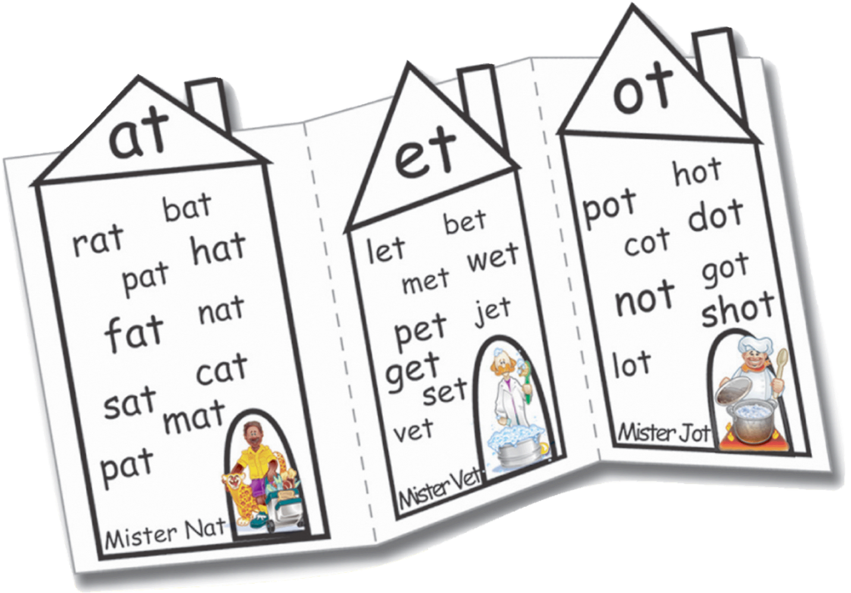
My Word Family Book

Name:___________________

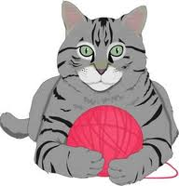
__at
Word | Picture | I read to my book buddy!
______________________  ----------------  ______________________ |  | ____
______________________  ----------------  ______________________ |  | ____
______________________  ----------------  ______________________ |  | ____
______________________  ----------------  ______________________ |  | ____
______________________  ----------------  ______________________ |  | ____

Choose two words from your list and write a silly sentence.
________________________________________________________
---------------------------------------------------------
________________________________________________________

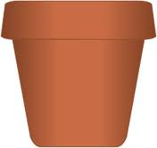
__ot
Word | Picture | I read to my book buddy!
______________________  ----------------  ______________________ |  | ____
______________________  ----------------  ______________________ |  | ____
______________________  ----------------  ______________________ |  | ____
______________________  ----------------  ______________________ |  | ____
______________________  ----------------  ______________________ |  | ____

Choose two words from your list and write a silly sentence.
________________________________________________________
---------------------------------------------------------
________________________________________________________

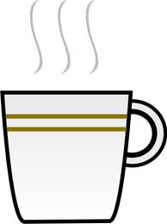
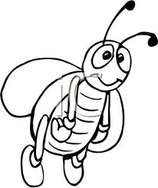
__ug
Word | Picture | I read to my book buddy!
______________________  ----------------  ______________________ |  | ____
______________________  ----------------  ______________________ |  | ____
______________________  ----------------  ______________________ |  | ____
______________________  ----------------  ______________________ |  | ____
______________________  ----------------  ______________________ |  | ____

Choose two words from your list and write a silly sentence.
________________________________________________________
---------------------------------------------------------
________________________________________________________

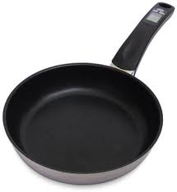
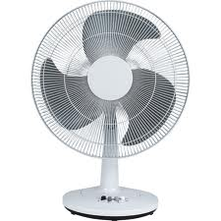
__an
Word | Picture | I read to my book buddy!
______________________  ----------------  ______________________ |  | ____
______________________  ----------------  ______________________ |  | ____
______________________  ----------------  ______________________ |  | ____
______________________  ----------------  ______________________ |  | ____
______________________  ----------------  ______________________ |  | ____

Choose two words from your list and write a silly sentence.
________________________________________________________
---------------------------------------------------------
________________________________________________________

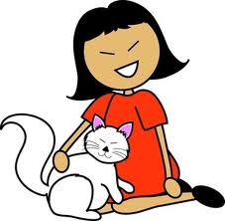
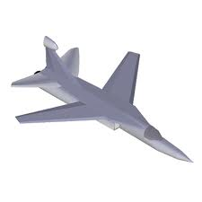
__et
Word | Picture | I read to my book buddy!
______________________  ----------------  ______________________ |  | ____
______________________  ----------------  ______________________ |  | ____
______________________  ----------------  ______________________ |  | ____
______________________  ----------------  ______________________ |  | ____
______________________  ----------------  ______________________ |  | ____

Choose two words from your list and write a silly sentence.
________________________________________________________
---------------------------------------------------------
________________________________________________________

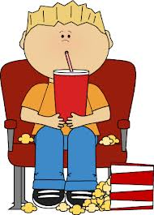
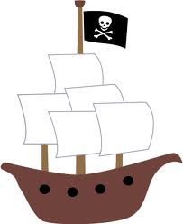
__ip
Word | Picture | I read to my book buddy!
______________________  ----------------  ______________________ |  | ____
______________________  ----------------  ______________________ |  | ____
______________________  ----------------  ______________________ |  | ____
______________________  ----------------  ______________________ |  | ____
______________________  ----------------  ______________________ |  | ____

Choose two words from your list and write a silly sentence.
________________________________________________________
---------------------------------------------------------
________________________________________________________

Wow! My book looks great!!!

What I like best about this word family book is
________________________________________________________
---------------------------------------------------------
________________________________________________________

I can tell someone put hard work into this book because
________________________________________________________
---------------------------------------------------------
________________________________________________________

My favorite page in my word family book is the ______ page because
________________________________________________________
---------------------------------------------------------
________________________________________________________

My friend________________ likes the ______ page the best because
________________________________________________________
---------------------------------------------------------
________________________________________________________

________________________________________________________
---------------------------------------------------------
________________________________________________________

Writing Rubric for My Sentence
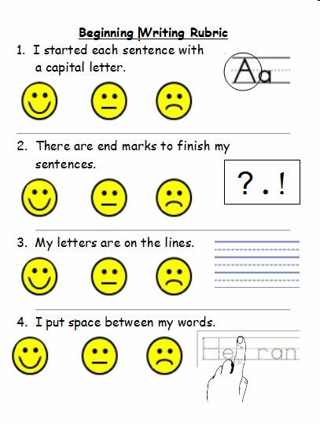

(This would be attached to the back of each page in the book for them to self-correct their sentence.)

